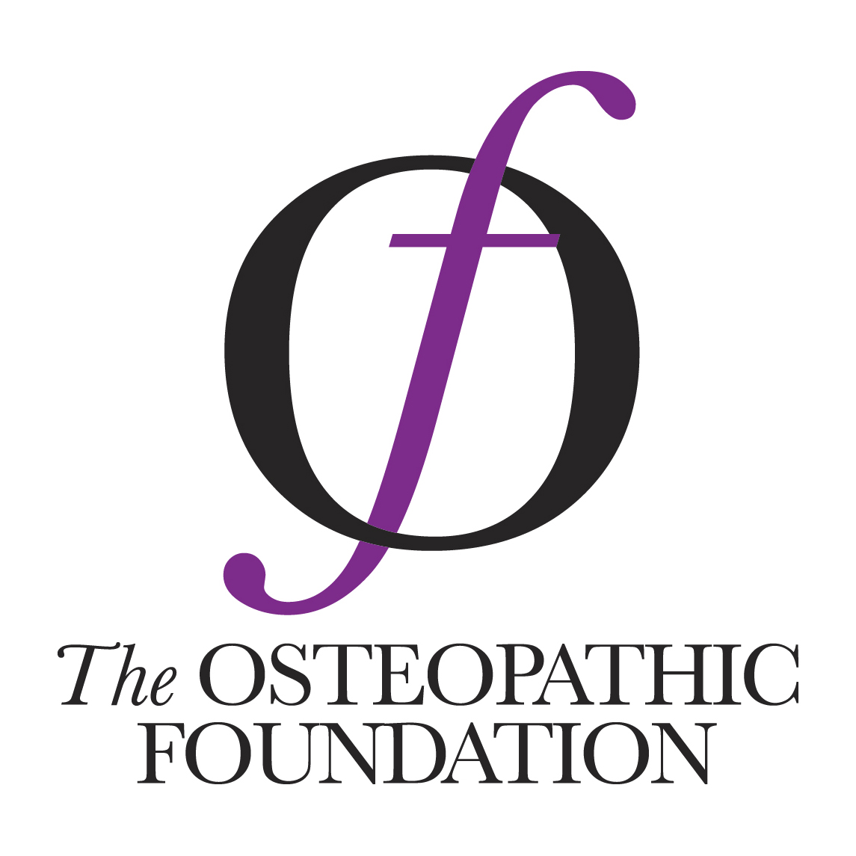
11th November 2019 – For immediate release

The Osteopathic Foundation announces successful bids in its second round of grants

The board of the Osteopathic Foundation (oF) is delighted to announce details of the successful bids for its second round of research funding to support the development of osteopathic practice and demonstrate its value to the public’s health.

All the bids were evaluated by the Board against strict criteria and five projects succeeded in their attempts to be funded.

Chair of the oF, Dr Jonathan Shapiro, said of the successful bids: “We chose projects with four aims in mind: to produce more evidence supporting osteopathic practice, develop new career pathways for osteopaths, support professional development, and enhance the scope of osteopathic practice.”

oF Manager Matthew Rogers added: “We were really impressed by the standard of the bids, and it was a hard task to choose the successful ones. In the end, all the best bids managed to combine science and care, and most encouraged close working between two or more organisations.”

The successful projects include; the first UK pilot to deploy osteopaths as First Contact Practitioners in the NHS, while a further project aims to develop a post-graduate qualification for osteopaths for these roles. Of the clinically based projects, one is looking at the effectiveness of osteopathic care for distressed infants, whilst another will assess the effectiveness of biopsychosocial pain management in osteopathic practice.

Of the bids supporting development within the profession, one project is aiming to create a competency framework to support osteopaths’ career development, whilst the other is exploring the development of a mentoring support framework for osteopaths throughout their careers. Both of these bids were submitted by the Osteopathic Development Group, the collaborative forum representing all the major osteopathic organisations in the UK.

For further information on any of these projects, and other work of the Osteopathic Foundation, please contact Matthew Rogers at the oF on Matthew@iOsteopathy.org.

Ends.

Note to editors
The Osteopathic Foundation (The OF) is a charitable trust set up to advance osteopathic practice by funding education, research and by promoting productive relationships both within and outside of the profession, for the benefit of the public. For more information about the work of the Osteopathic Foundation and is grant awards scheme, please contact Matthew Rogers Matthew@iOsteopathy.org or Halo Garrity Halo@iOsteopathy.org
https://www.iosteopathy.org/ the-osteopathic-foundation/

